[**TryHackMe - OSINT : Sakura Room**](https://security.throyr.com/posts/osint_thm/)

Table of Contents

* [Introduction](https://security.throyr.com/posts/osint_thm/#introduction)
* [Tip-off](https://security.throyr.com/posts/osint_thm/#tip-off)
* [Reconnaissance](https://security.throyr.com/posts/osint_thm/#reconnaissance)
* [Unveil](https://security.throyr.com/posts/osint_thm/#unveil)
* [Taunt](https://security.throyr.com/posts/osint_thm/#taunt)
* [Homebound](https://security.throyr.com/posts/osint_thm/#homebound)

**Introduction**

This writeup is about osint Sakura Room from TryHackMe.

This is a room made with Osint Dojo, an Osint security website.

**Tip-off**

So, lets begin. We are asked the username of the attacker, and we are given a link to a picture.

If you observed well, it is a github link. So, let’s try to inspect code source :

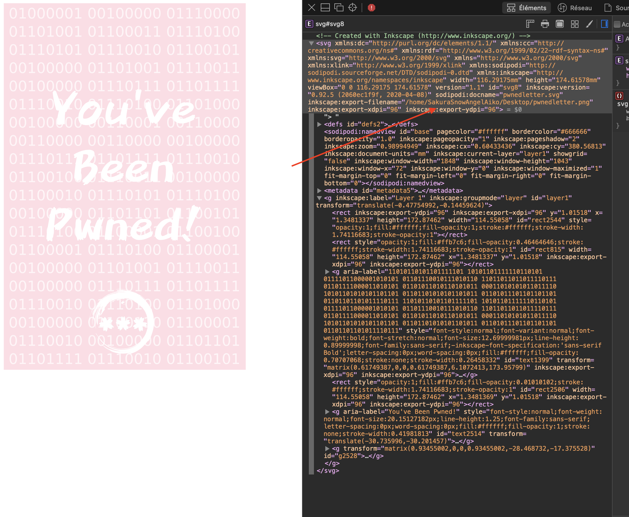

Answer : SakuraSnowAngelAiko

**Reconnaissance**

Okay, so, the first thing to do : a Google search with the username we got.

And we got a github :

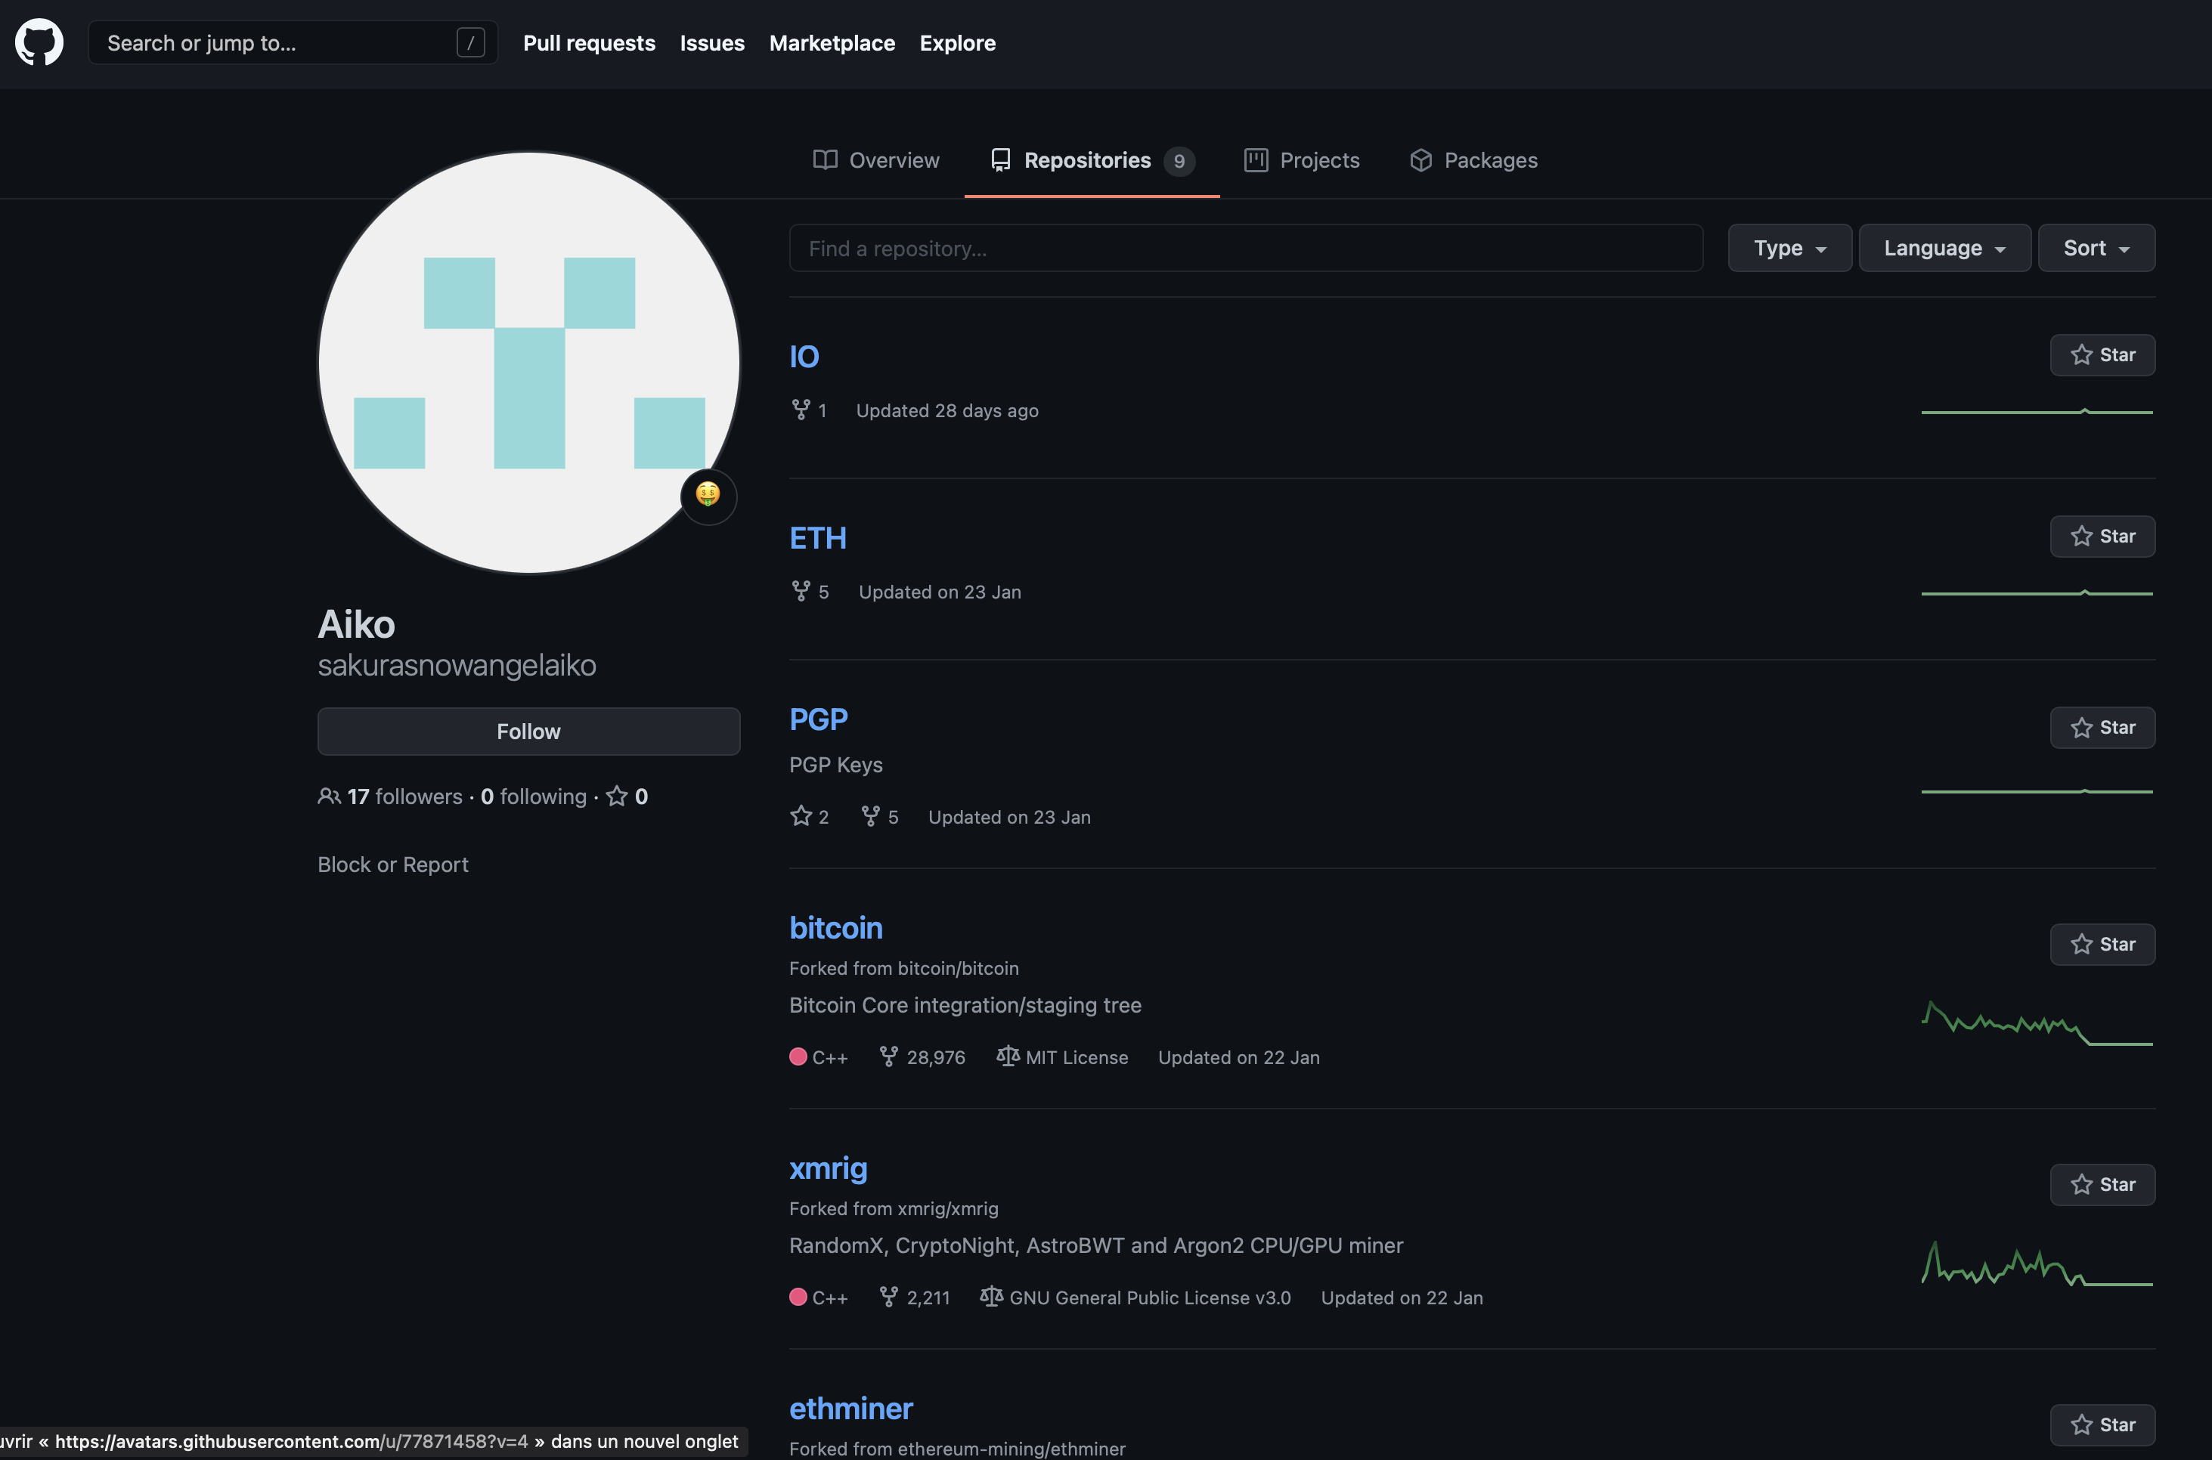

So, after browsing the repositories, we found a PGP key :

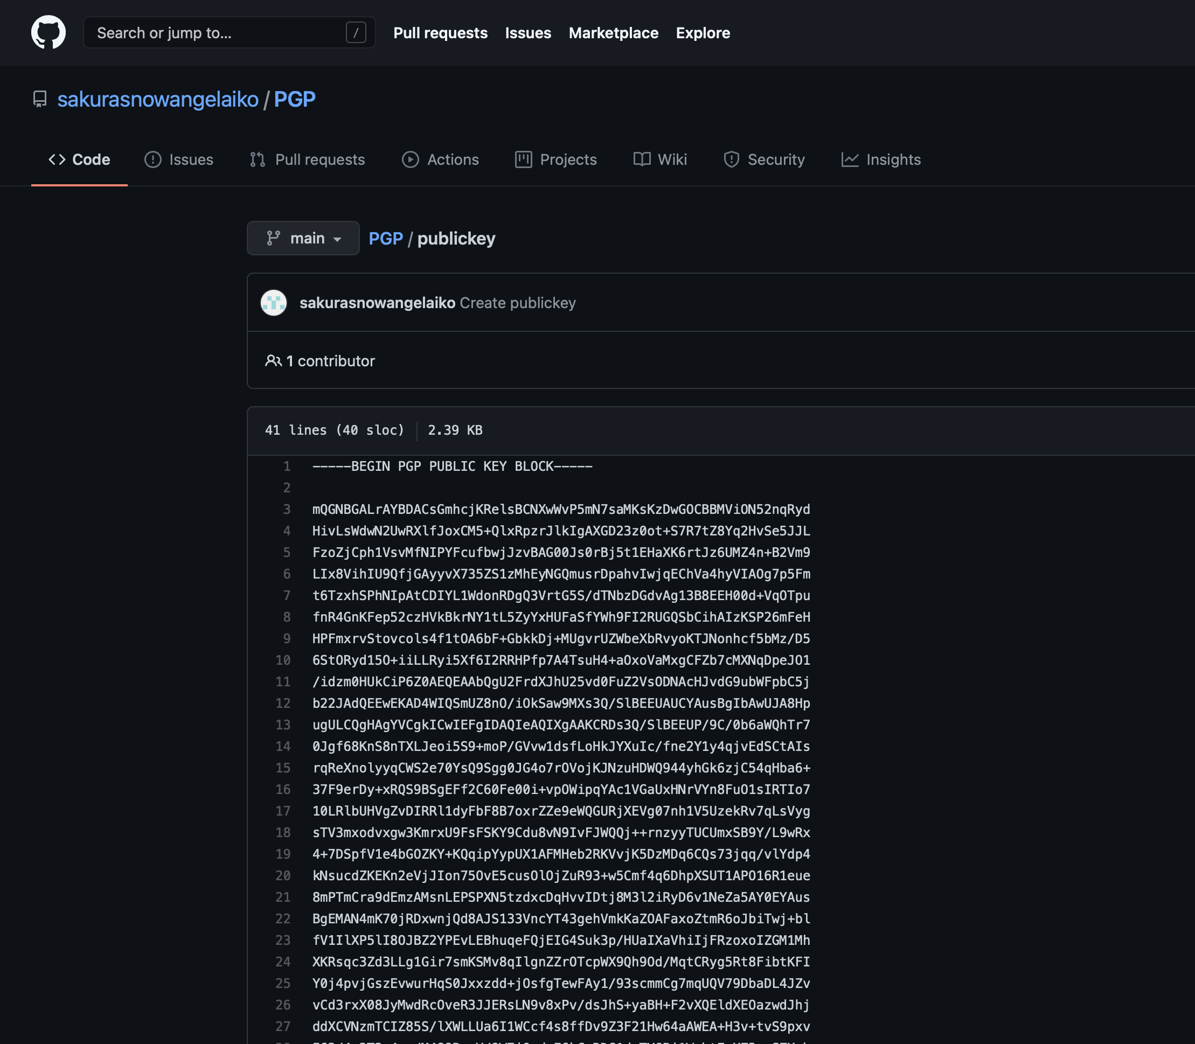

You can copy it and after a quick look on Google, you will find tools to decrypt PGP pubic keys :

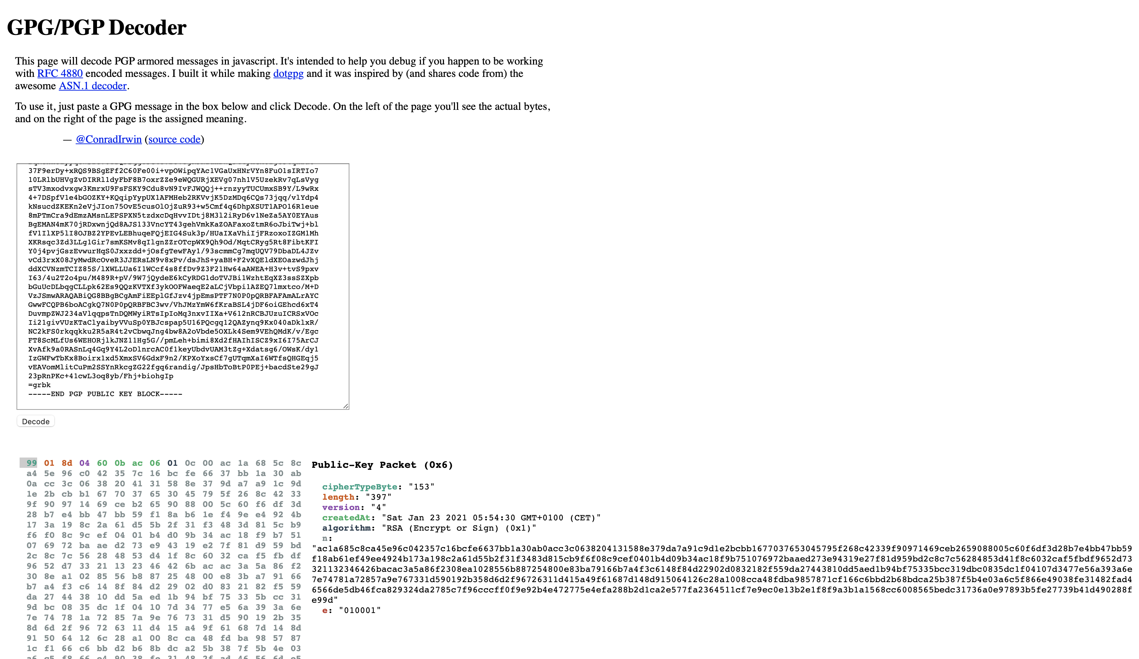

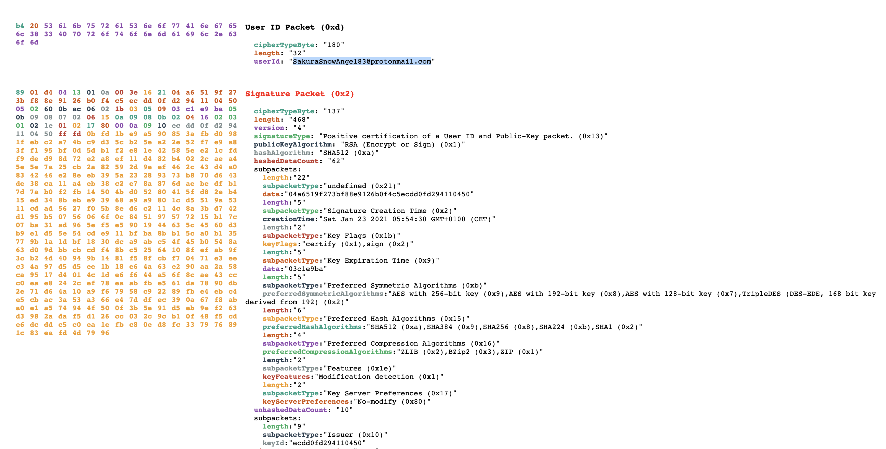

Answer : SakuraSnowAngel83@protonmail.com

After another search on Google, we found username real name because of two social medias profiles : Linkedin and Twitter.

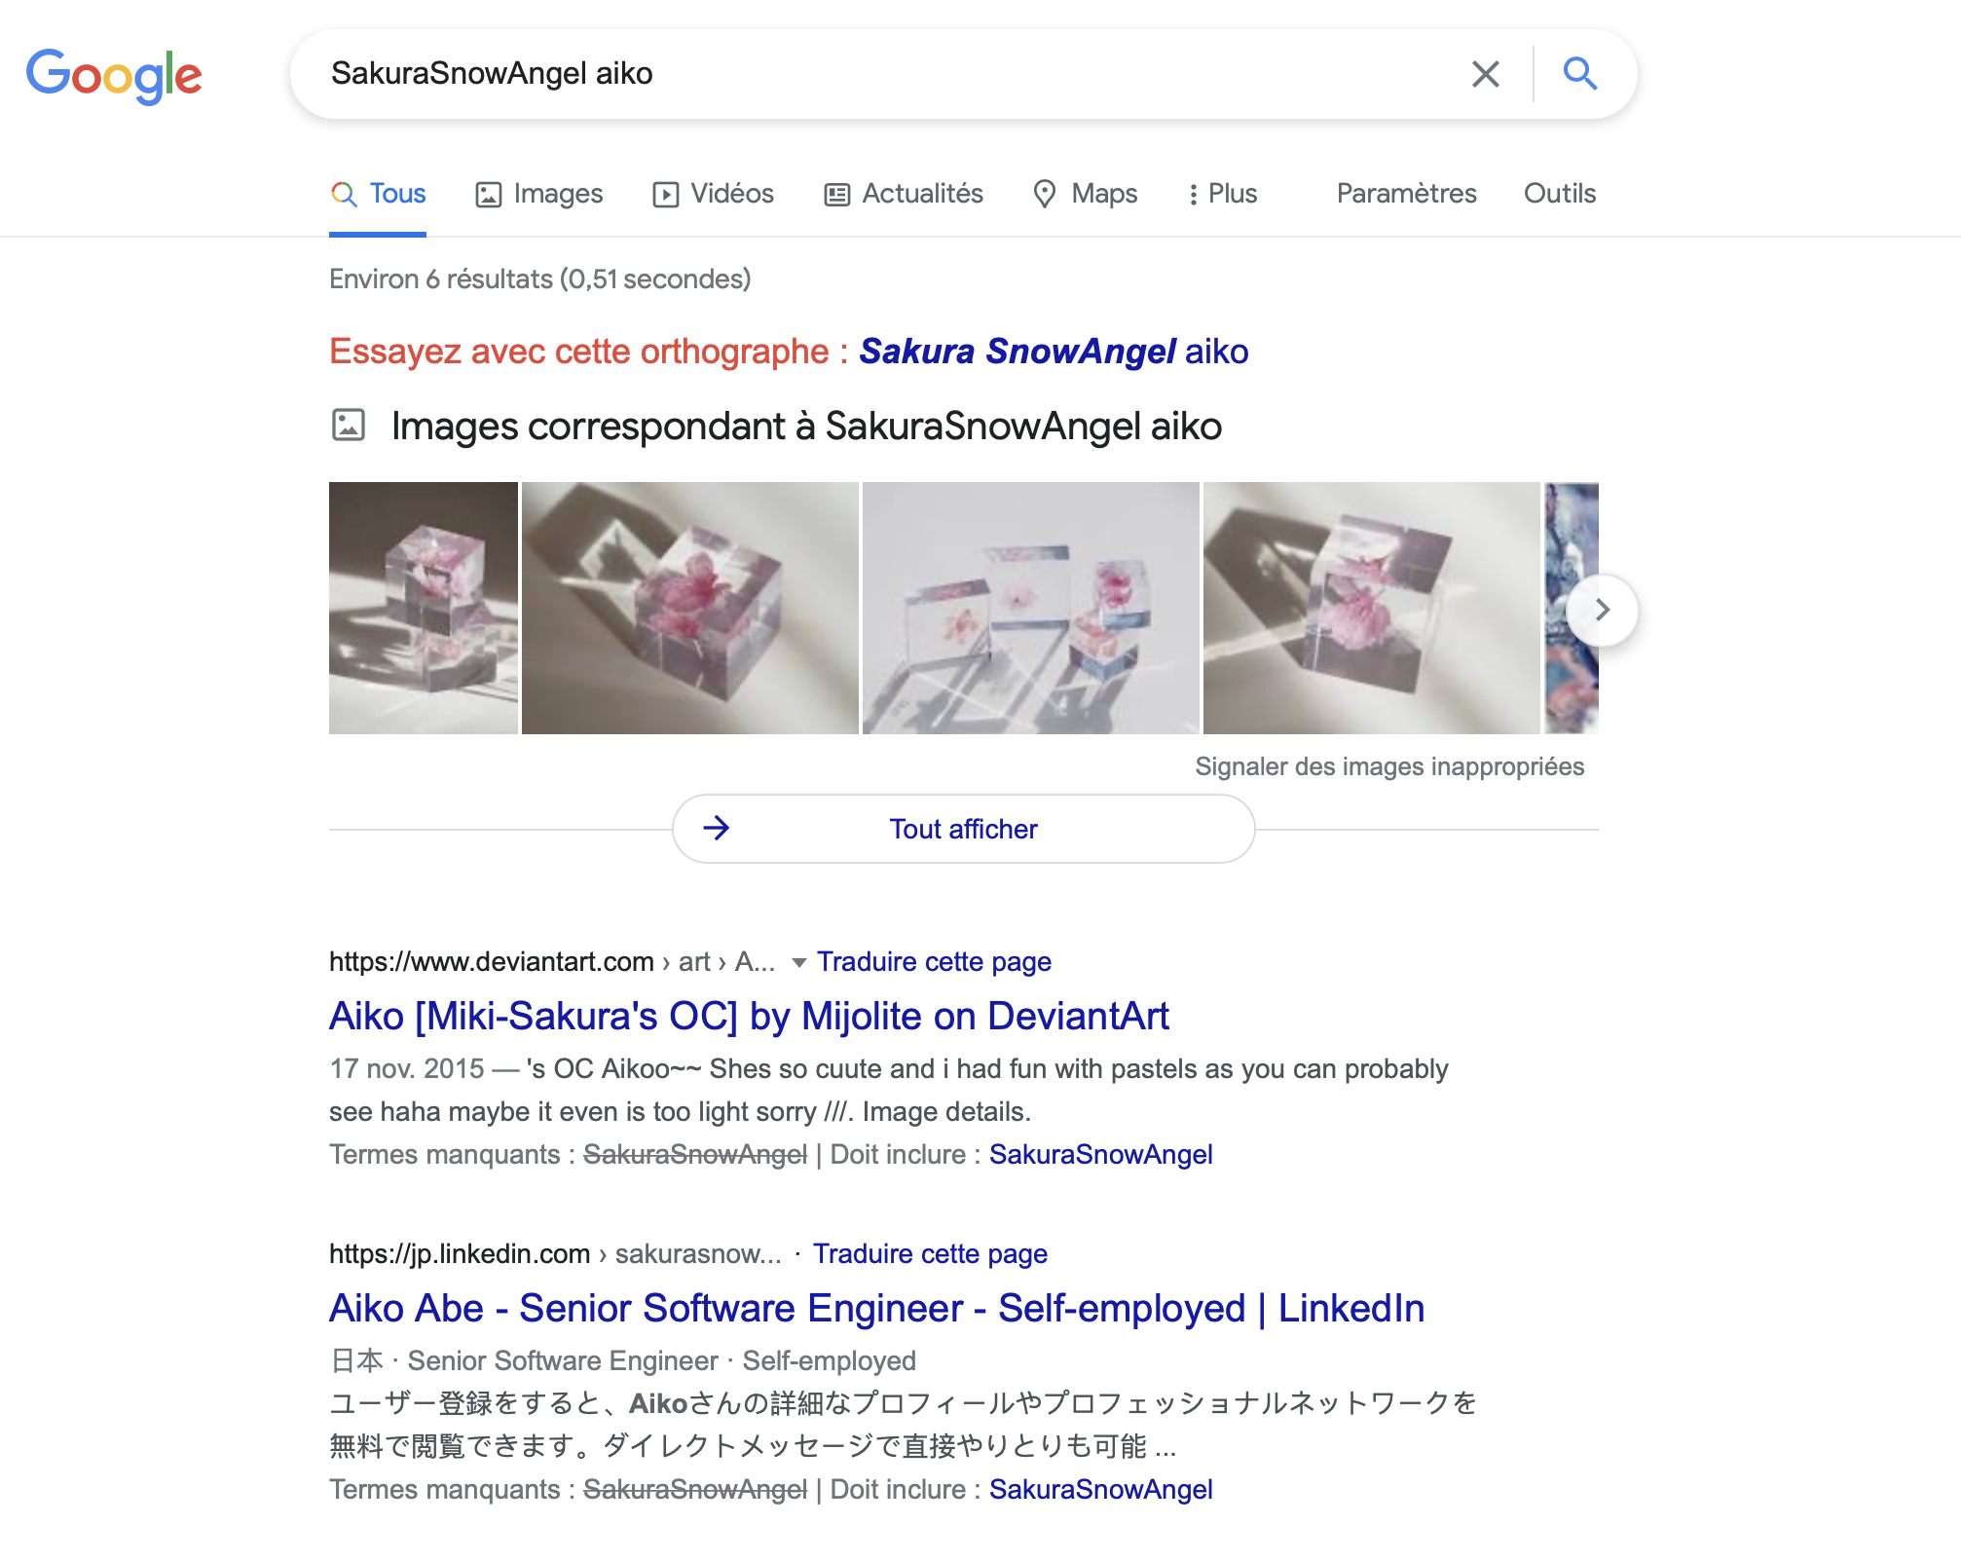

Answer : Aiko Abe

**Unveil**

Okay, so now, we come back to Github repository, and browse them again.

We found an Eth repo, and if you click on the history button, you got the answer for the attacker’s cryptocurrency wallet address :

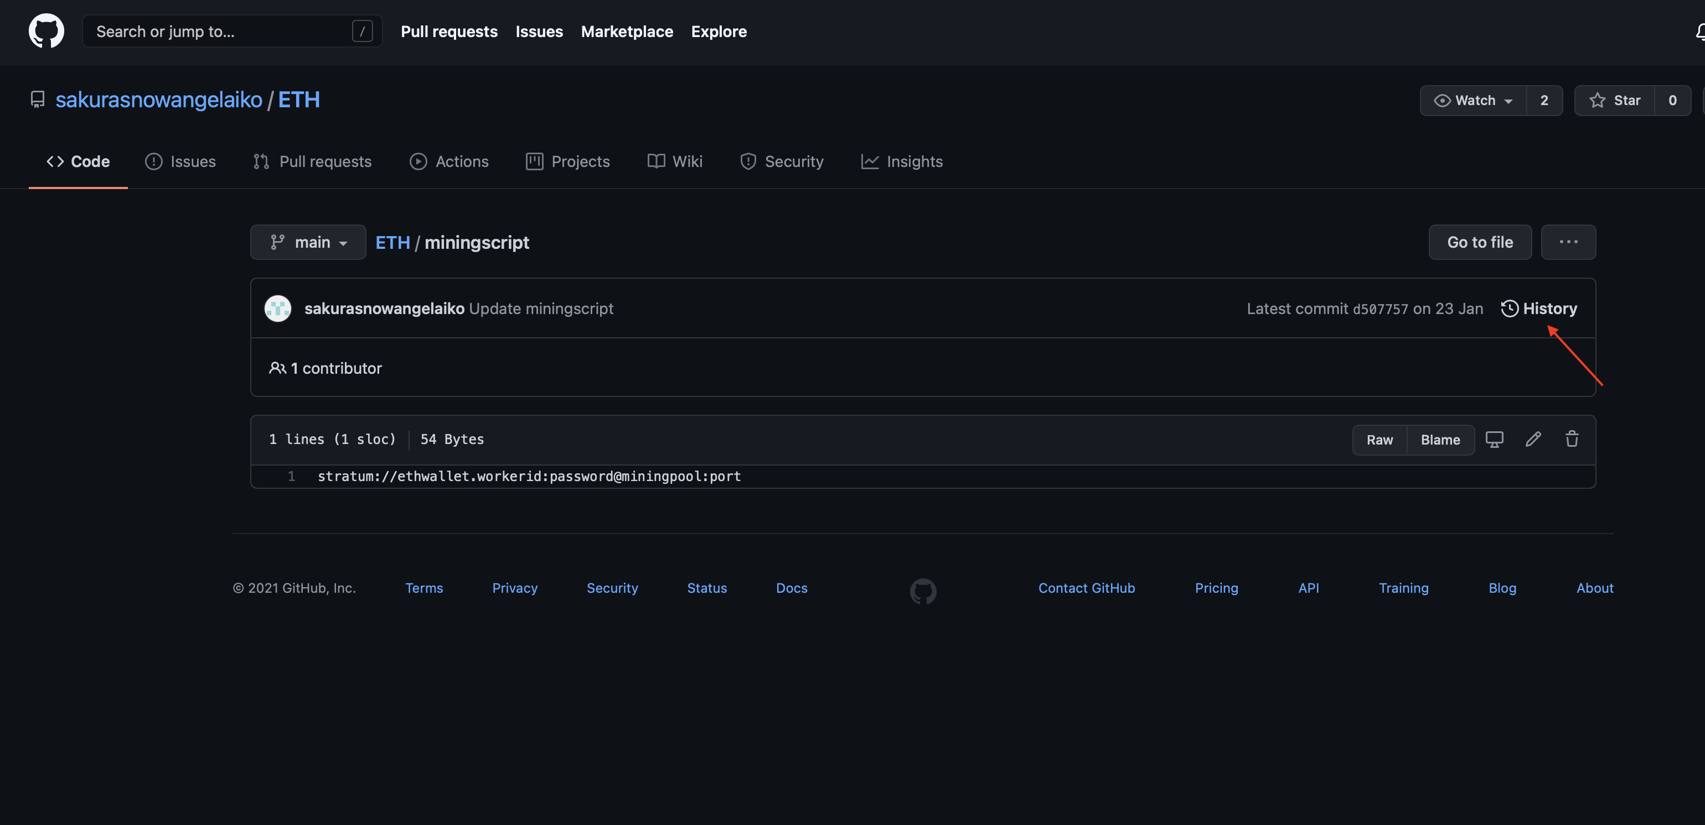

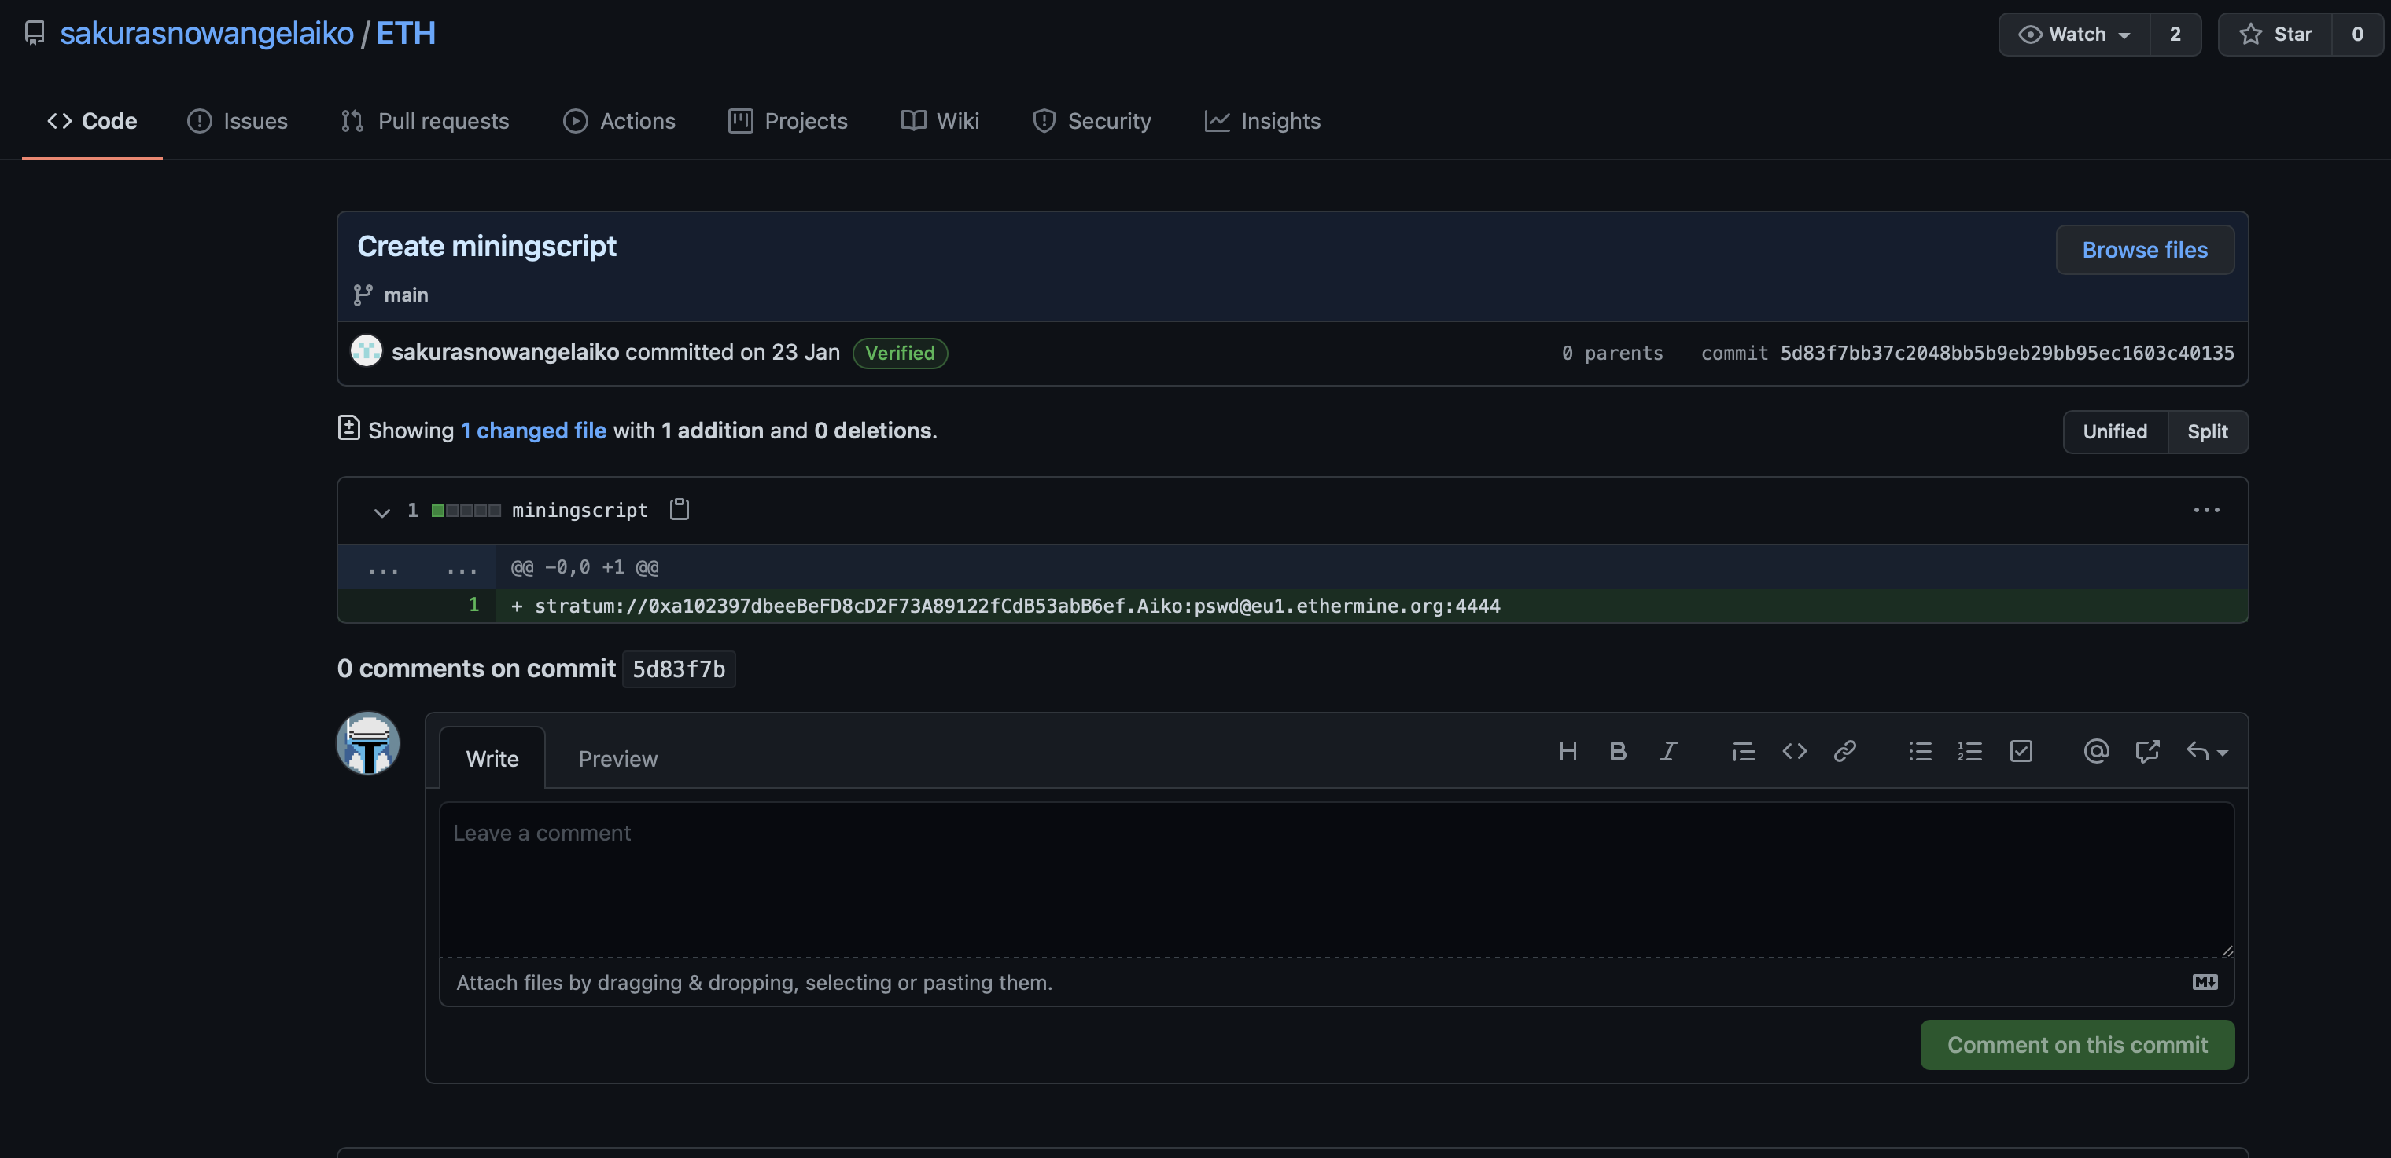

So, we also know which mining pool is used. Google it, and found a website. You can copy/paste the wallet address :

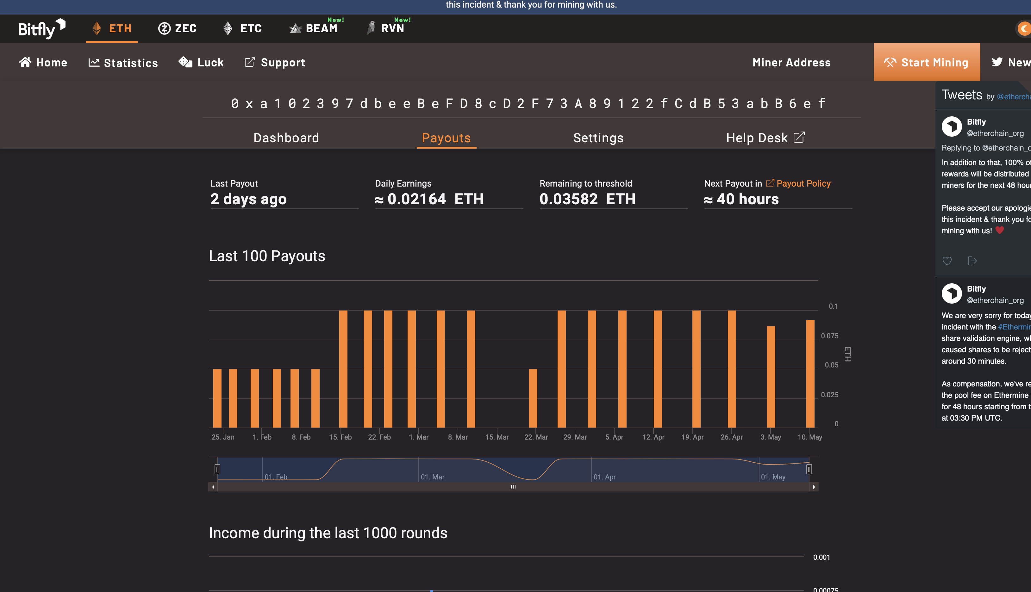

Answers :

- Ethereum

- 0xa102397dbeeBeFD8cD2F73A89122fCdB53abB6ef

- Ethermine

- Tether

**Taunt**

As said earlier, we found two social medias, including Twitter. So go on user profile (@AikoAbe3) :

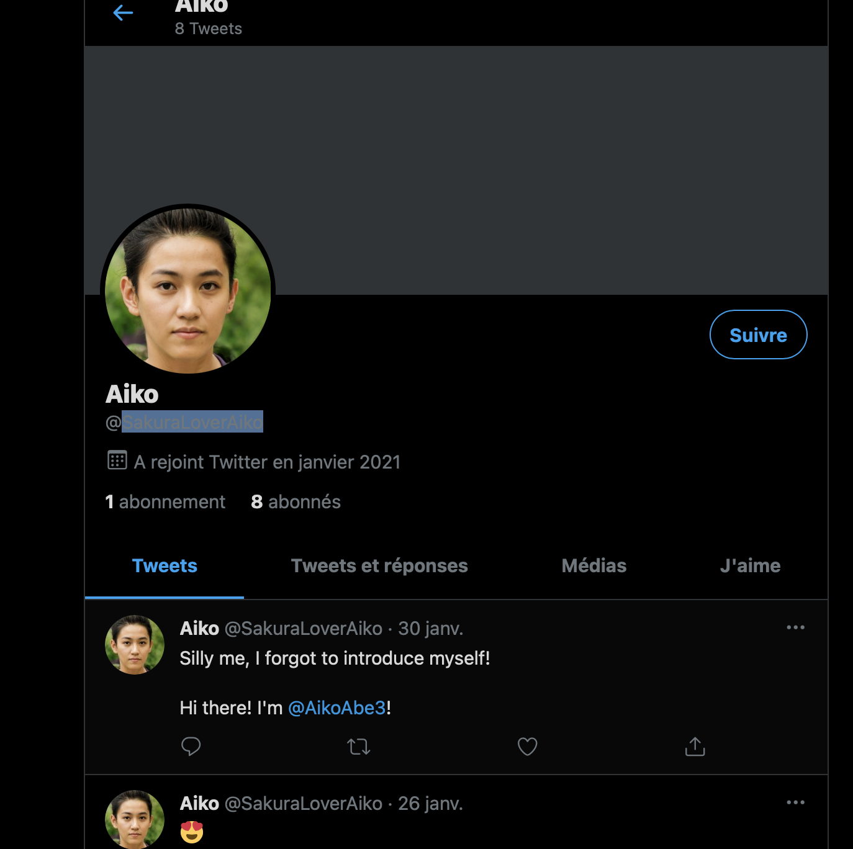

Okay, to be honnest, this one took me a little longer to find. In one tweet, the user had two words in upper cases : DEEP and PASTE.

So, I finally googled it, found that it was an onion website. So, open Tor and paste the url for DeepPaste website.

Then, you can search the md5 hash which is on the first tweet (be patient) :

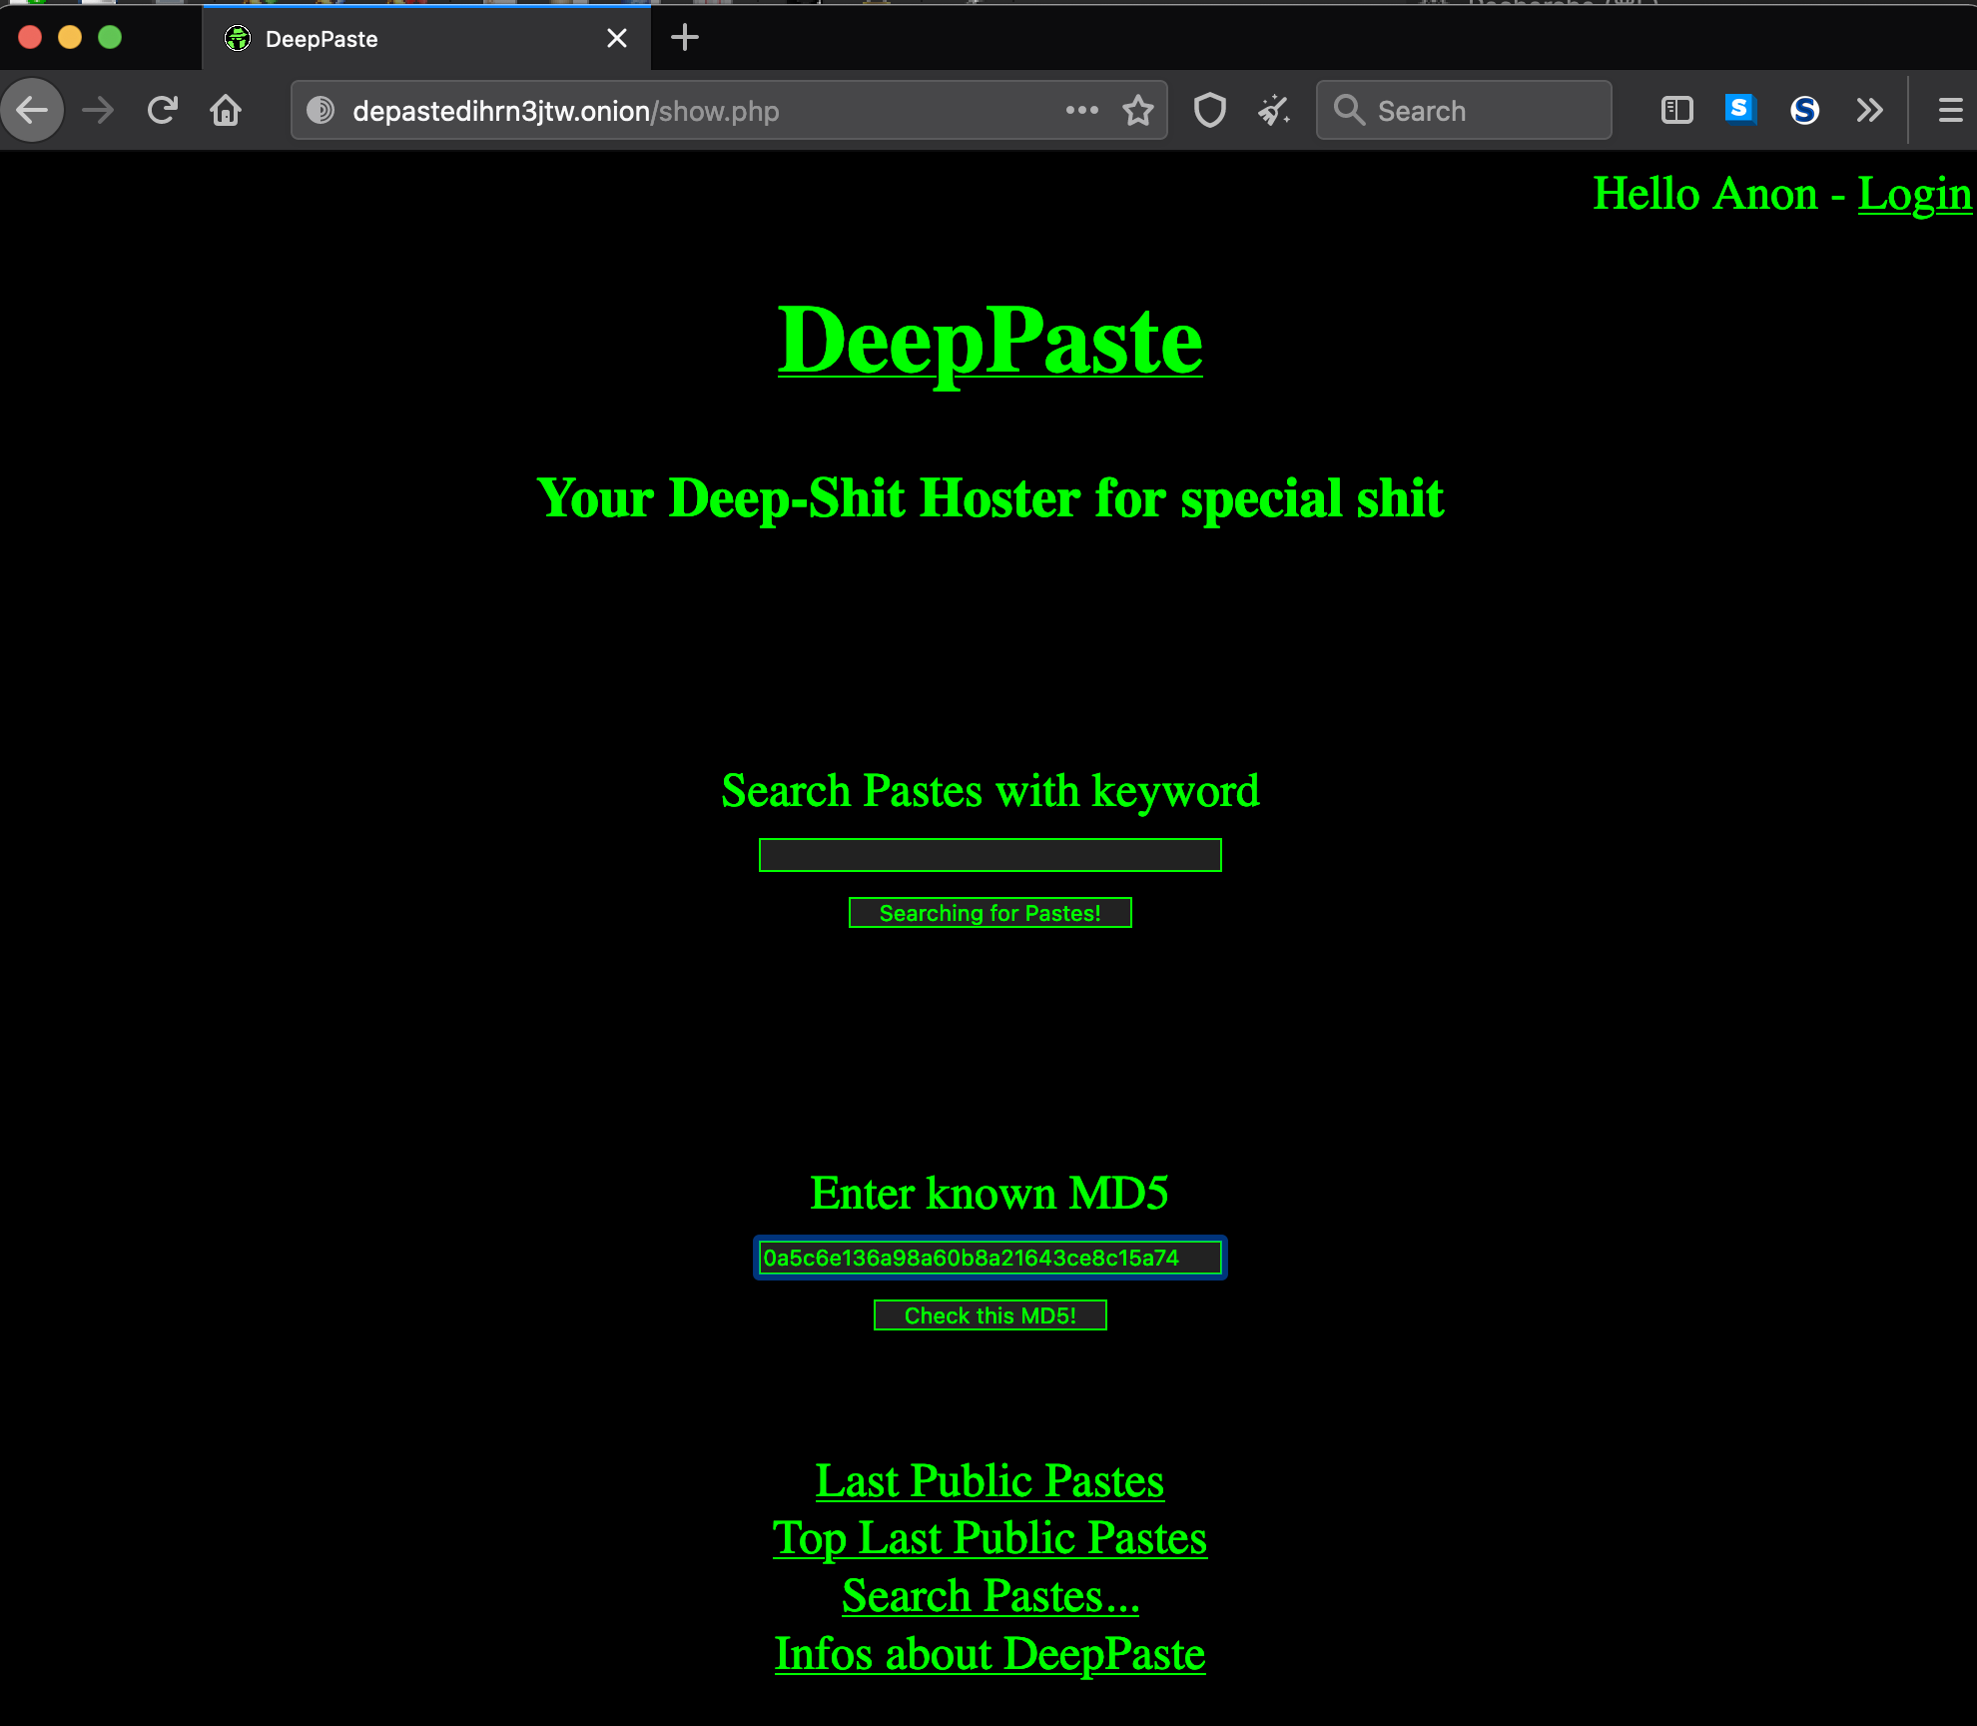

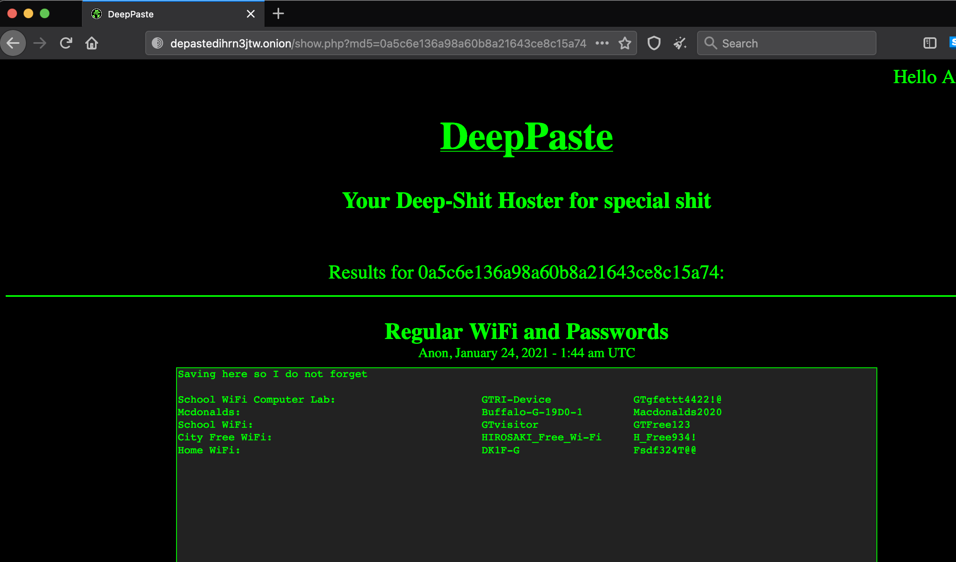

Finally, the last flag for this section. Try to search for “find wifi ssid and bssid online” on Google, and you will get this website [https://wigle.net](https://wigle.net/)

Create an account, and you will be able to search by advanced queries. Look for the SSID, and you got the bssid :

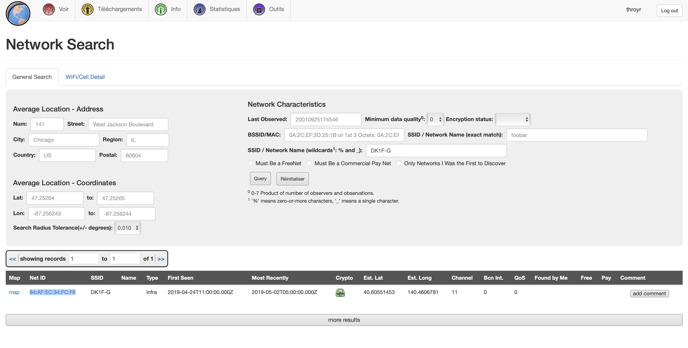

Answers :

- SakuraLoverAiko

- http://depastedihrn3jtw.onion/show.php?md5=0a5c6e136a98a60b8a21643ce8c15a74

- 84:af:ec:34:fc:f8

**Homebound**

Last but not least !

So, in twitter account, you will find one tweet, and a city mentionned : Bethesda.

Look for Bethesda airport flight to Japan :

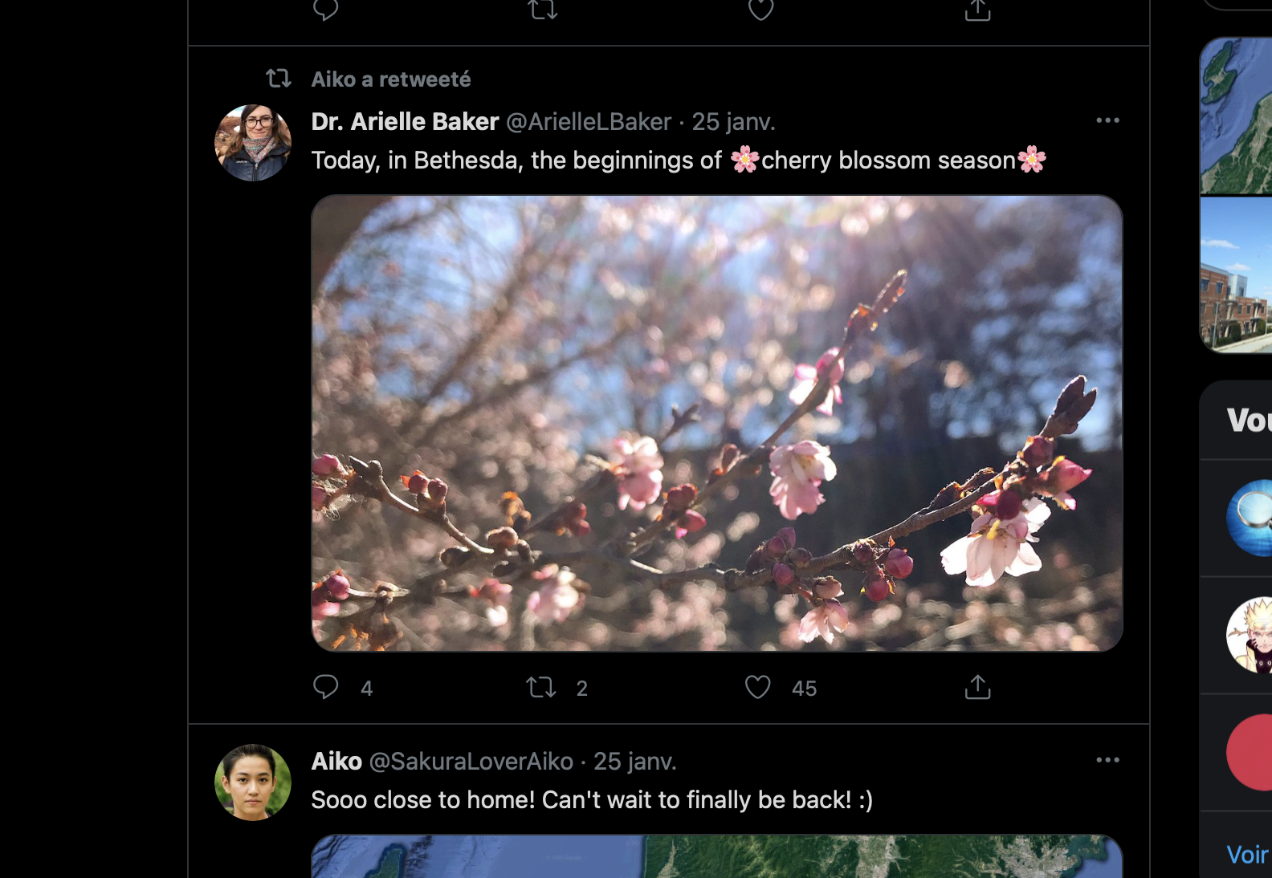

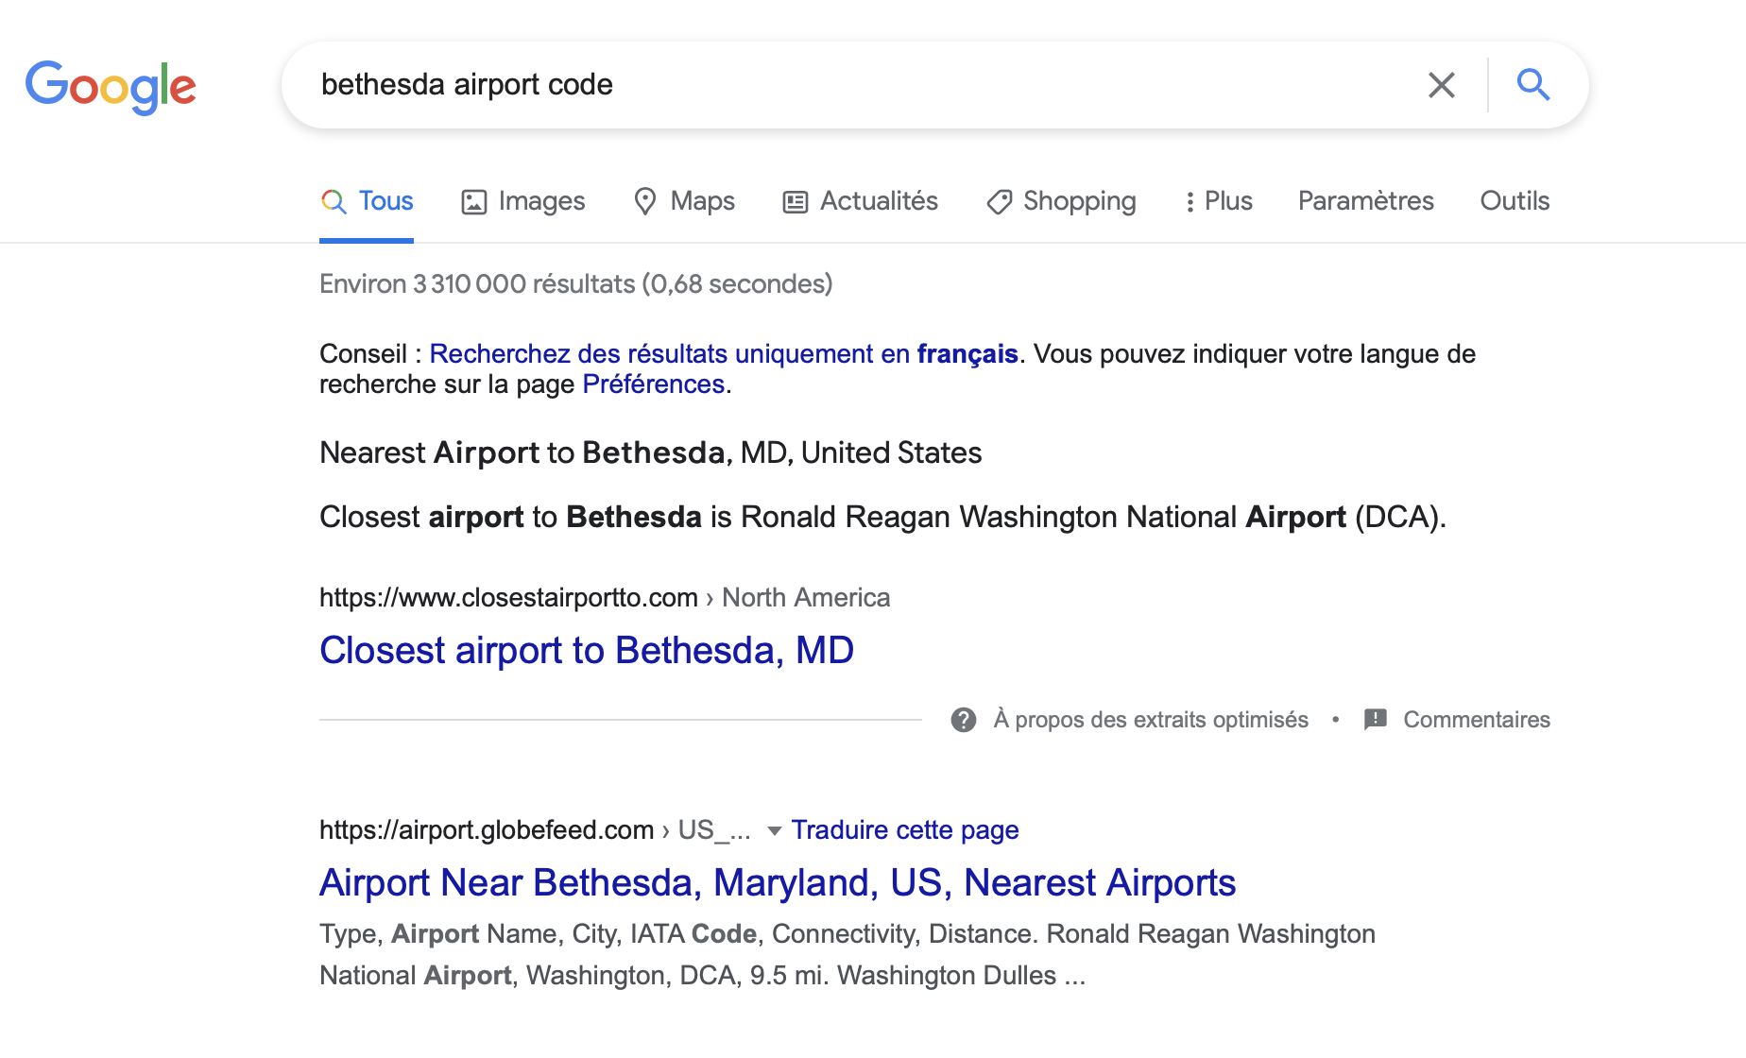

In last section, we found the bssid of the user. We also found, that location : Hirosaki, in Japan.

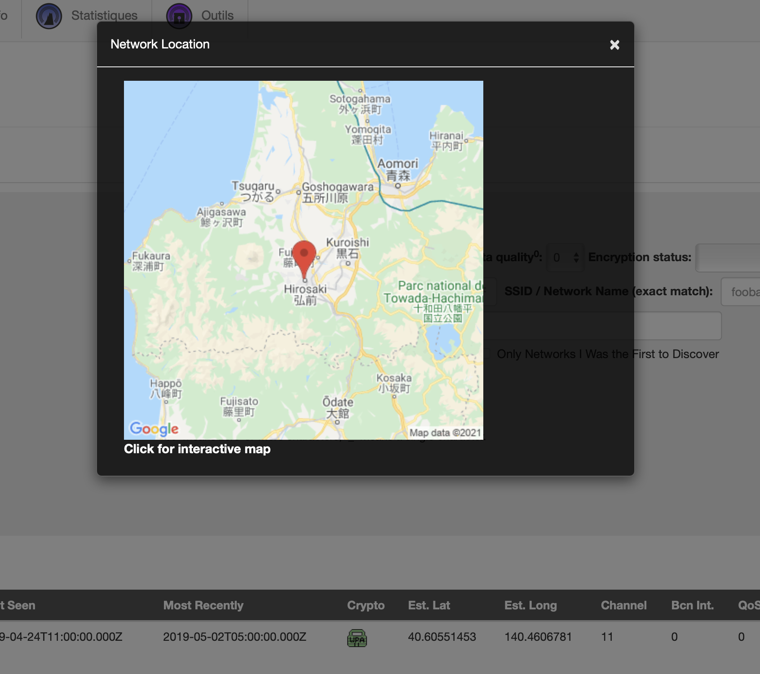

So, I did a quick flight simulation, and got this result :

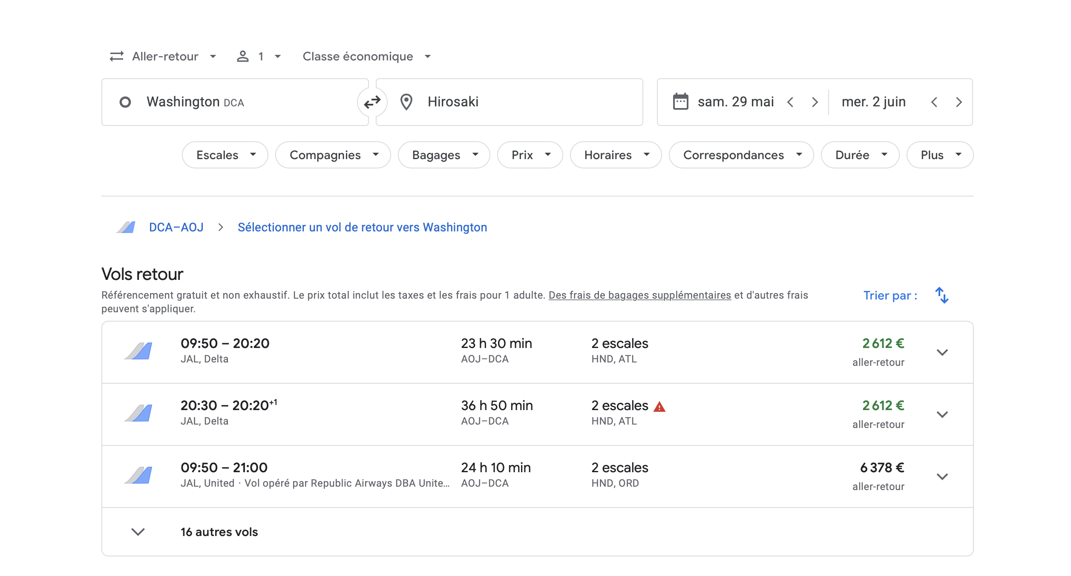

We found that their are 2 airport stops on the way : HND and ATL. HND is definitely the one we are looking for.

Last one, is about the lake. Go on Google Maps, and here you are :

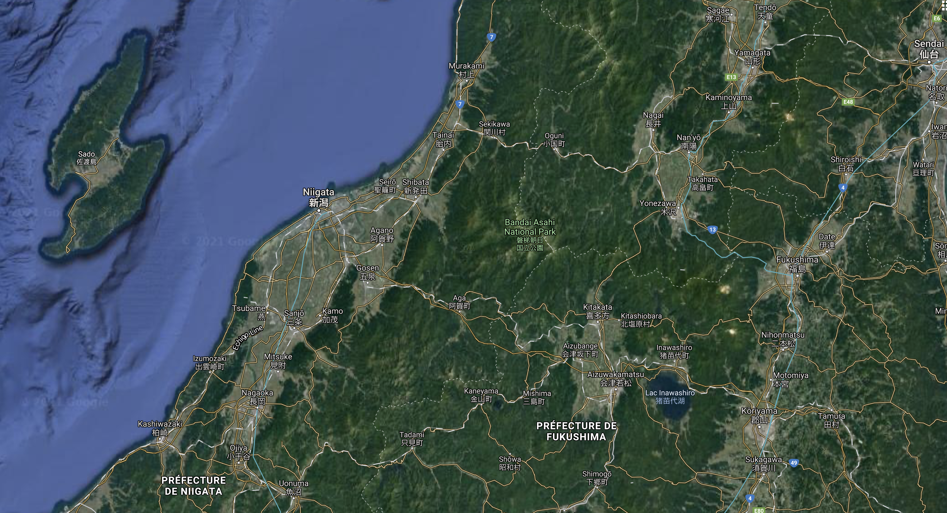

Answers :

- DCA

- HND

- Lake Inawashiro

- Hirosaki